Application Log Analytics Dashboard
Technical Documentation
Centralized log search, visualization and alerting for Java services using OpenSearch and Grafana
Table of Contents
1. Specifications 3
1.1 Functional requirements 3
1.2 Non-functional requirements 3
1.3 REST APIs 3
1.4 Database design (PostgreSQL) 4
1.5 Log format 4
2. Summary 4
3. Prerequisites 5
3.1 Software 5
3.2 Accounts and access 5
3.3 Environment variables 5
3.4 Knowledge 5
4. Limitations 5
5. Architecture 6
5.1 Target Architecture 6
6. Tools 8

1. Specifications

1.1 Functional requirements
ID | Requirement
FR-1 | Collect logs from 1-2 Java services into a central store
FR-2 | Search logs by service, log level, keyword and time range
FR-3 | Register and list monitored services
FR-4 | Create alert rules (log level, threshold, time window)
FR-5 | Check alert rules every minute and record an alert when a threshold is crossed
FR-6 | Send an Email or Slack notification when an alert fires
FR-7 | View and resolve fired alerts
FR-8 | Show log dashboards in Grafana (logs per service, error count, log level split)

1.2 Non-functional requirements
Area | Requirement
Deployment | Fully Dockerized; runs with a single "docker compose up"
Testing | Unit test coverage above 70%
Performance | Log search returns within 2 seconds for a 24-hour window
Security | API key on all REST endpoints; no secrets in source code
Documentation | Swagger UI for APIs; this document for design

1.3 REST APIs
# | Endpoint | Method | Purpose
1 | /api/v1/services | POST, GET | Register and list services
2 | /api/v1/logs/search | GET | Search logs. Params: service, level, keyword, from, to, page, size
3 | /api/v1/alert-rules | POST, GET | Create and list alert rules
4 | /api/v1/alerts | GET | List fired alerts
5 | /api/v1/alerts/{id} | PATCH | Mark an alert as resolved

1.4 Database design (PostgreSQL)
The API stores only small, relational data in PostgreSQL. Log data itself lives in OpenSearch.
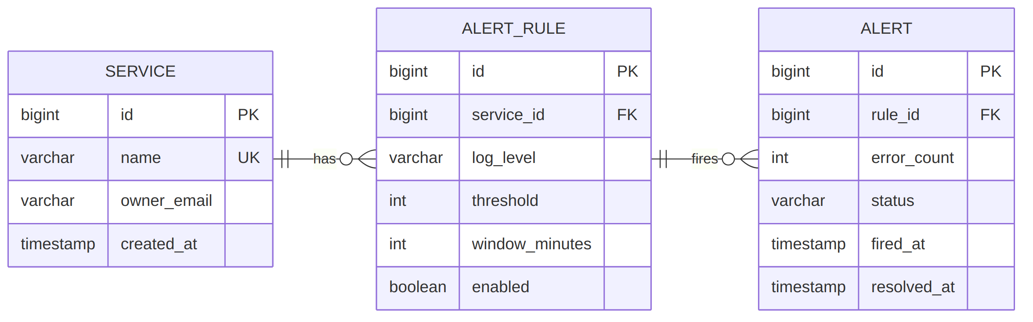
Figure 1: Database ER diagram
Table | Purpose
SERVICE | A monitored Java service and its owner email
ALERT_RULE | Condition to check: log level, threshold count, time window, enabled flag
ALERT | A fired alert with error count, status (OPEN or RESOLVED) and timestamps

1.5 Log format
Each service writes one JSON object per log line:
{
"@timestamp": "2026-09-21T10:15:30.123Z",
"service": "order-service",
"level": "ERROR",
"message": "Failed to create order",
"traceId": "a1b2c3d4"
}

Logs are stored in OpenSearch in daily indices named app-logs-YYYY.MM.DD.

2. Summary
Teams running Java services often debug by reading log files on each server. This is slow, does not scale, and nobody is warned when errors increase.
This project provides a small, centralized log analytics solution:
- Fluent Bit collects logs from Java services.
- OpenSearch stores the logs and makes them searchable.
- Grafana shows dashboards.
- A Spring Boot API lets users search logs, register services and define alert rules. Every minute it checks the rules and sends a notification when a threshold is crossed.
- PostgreSQL stores services, alert rules and fired alerts.

3. Prerequisites

3.1 Software
Item | Version
Java (JDK) | 21
Maven | 3.9+
Docker and Docker Compose | Latest stable
Git | Any recent version

3.2 Environment variables
Variable | Purpose
DB_URL, DB_USER, DB_PASSWORD | PostgreSQL connection
OPENSEARCH_URL | OpenSearch address
API_KEY | Key required by REST clients
SLACK_WEBHOOK_URL or SMTP_* | Notification channel

4. Limitations
- Small scale: designed for 1-2 services. It is not tested for high log volume.
- Single node: OpenSearch, PostgreSQL and the API run on one server. There is no high availability or automatic failover.
- Logs only: no metrics or distributed tracing.
- Basic alerting: only count-based rules (for example, more than 50 errors in 5 minutes). No anomaly detection.
- Simple security: one shared API key. There are no user accounts or role-based access.
- No log masking: sensitive data in logs (emails, card numbers) is not hidden, so services must avoid logging it.
- Fixed log format: services must write JSON logs in the format in section 1.5.
- No custom UI: users work through Swagger UI, REST calls and Grafana.
- Alert delay: rules are checked once per minute, so alerts can be up to one minute late.
- Fixed retention: logs are kept for a fixed number of days, then deleted.

5. Architecture

5.1 Target Architecture
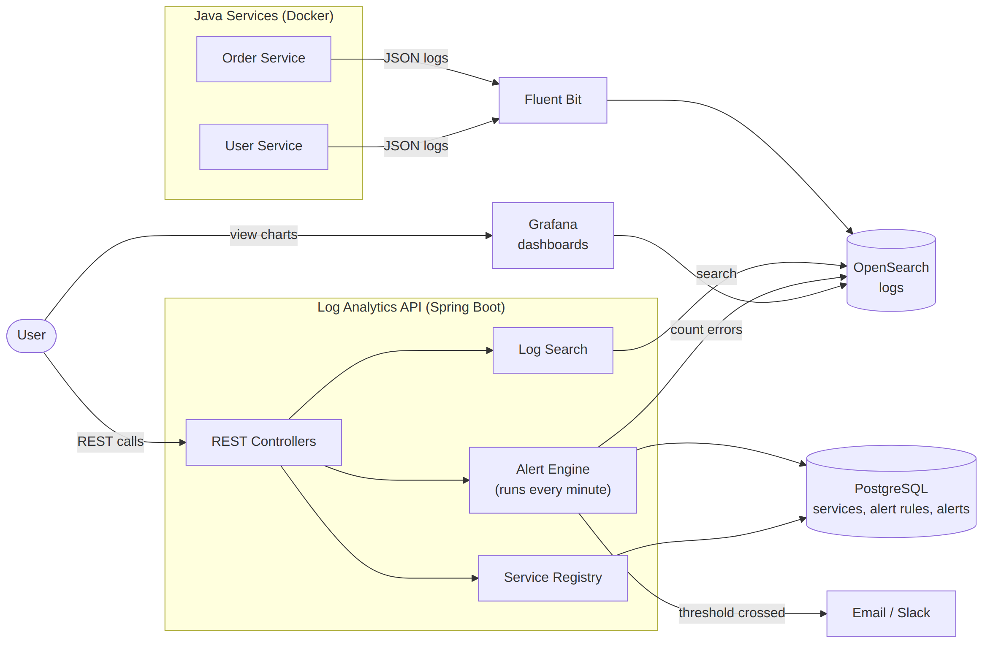
Figure 2: Target architecture
Components
Component | Responsibility
Java Services | Write JSON logs to stdout using Logback
Fluent Bit | Reads container logs and sends them to OpenSearch
OpenSearch | Stores logs and answers search queries
Log Search | Builds OpenSearch queries from API parameters
Service Registry | Saves service details in PostgreSQL
Alert Engine | Every minute: loads enabled rules, counts matching logs, saves an alert and sends a notification
PostgreSQL | Stores services, alert rules and alerts
Grafana | Dashboards on top of OpenSearch

Alert flow
- The scheduler runs every minute.
- It loads all enabled alert rules from PostgreSQL.
- For each rule, it counts matching logs in OpenSearch for the rule's time window.
- If the count is above the threshold, it saves an alert in PostgreSQL and sends an Email or Slack message.
- A user reviews the alert with GET /alerts and closes it with PATCH /alerts/{id}.

Deployment
All components run as containers in Docker Compose on one EC2 instance.
Container | Port
log-analytics-api | 8080
grafana | 3000
opensearch | 9200 (internal only)
postgres | 5432 (internal only)

6. Tools
Category | Tool | Use
Language | Java 21 | Application code
Framework | Spring Boot 3 (Web, Data JPA, Scheduling, Validation) | REST APIs and scheduler
Database | PostgreSQL | Services, rules, alerts
Log store | OpenSearch | Log storage and search
Log shipper | Fluent Bit | Collect and forward logs
Dashboards | Grafana | Charts on log data
Logging | Logback (JSON encoder) | Structured logs in Java services
Build | Maven | Build and dependency management
Testing | JUnit 5, Mockito, JaCoCo | Unit tests and coverage report
API docs | springdoc-openapi (Swagger UI) | Interactive API documentation
Containers | Docker, Docker Compose | Packaging and deployment

